Lab #1
Intro to ModelSim and QtSpim

Purpose:

The primary purpose of the lab is to teach the student about the specific development system in use for the MIPS processor and for digital design. In the process, the student will also unavoidably notice that there a number of senseless ‘gotchas’ to making the sytems work correctly that must be learned. An apparent waste, but there is an important lesson in that, as well. Learning a new system inevitably means ingesting information specific to that system only. It is one of the curses of engineering: knowledge with limited application and short life span.
The secondary purpose is for the student to gain facility in boldly stringing assembly language instructions together to achieve meaningful activity.

Preparation:

Very little preparation is required. You may just go to the lab and carry out the tasks enumerated. However, you will find your understanding enhanced if you allow yourself a little time to experiment with the various commands and procedures. If you get some ideas beforehand of what you might like to try, it could be an especially productive session.

Procedure:

QtSpim/PCSpim Tutorial
- At one of the workstations BA 205, perform the usual log-in. Download the swap.asm file from the class web-site.
- QtSpim introduction: From the Start:Programs menu, click on LabApps, then QtSpim. As QtSpim loads, it automatically loads a program called exception.s which contains code to execute when a significant error occurs, which is not to say that they don’t trust you to not mess up. They just know that we all will, eventually. When the main window appears, choose Open from the File menu. Navigate to the My Documents folder and choose swap.s. The bottom pane of the main window should report that the file was successfully loaded. See figure following.

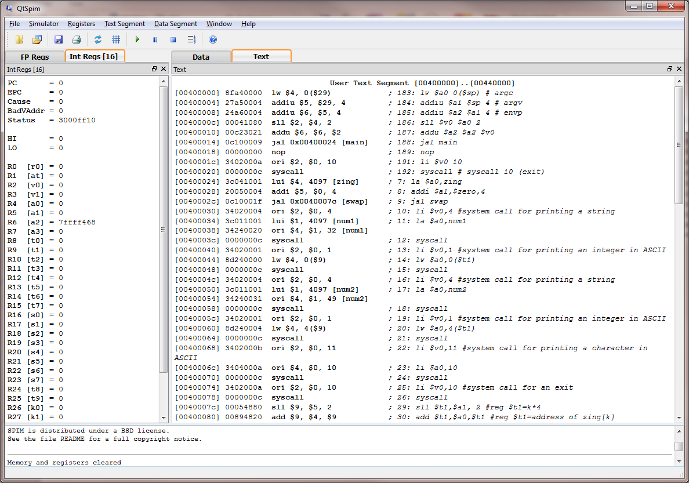

- This program initializes 8 consecutive words (an array) in memory with the integers 0 through 7. It calls this array ‘zing’. The program swaps the contents of zing[4] and zing[5] and reports the new contents on the console window. Of course, you are not yet in a position to understand many of the instructions that do this. We are just demonstrating features of QtSpim. You will be able to also see the activity of the program reflected in the register contents and memory contents which are displayed.
- The left pane of the program display shows all the register contents. The names by which we are learning them are shown in parentheses. The primary name used here is Rnn. For example, the primary name R16 is referred to in the textbook as $s0, and you can see s0 in parentheses. The R prefixed names are present to help understand the instructions in the next pane down. The program counter (PC) at the beginning is pointing at code for handling exceptions (interrupts or problems). This code is automatically retained from the exception.s file which was first automatically loaded when QtSpim began to run. You can see the code in the area where the program counter is pointing in the right pane. You may notice that the code often looks odd:

[00400010] 00c23021 addu $6, $6, $2 ; 187: addu $a2 $a2 $v0
[00400014] 0c100009 jal 0x00400024 [main] ; 188: jal main

The comments to the right, preceded by a semicolon (;) show the original source code. The register names we know are typically replaced by a number which reflects the number for the register used in the instruction itself (the fields right after ‘addu’ for instance). The swap.asm has given the label ‘main’ to the first execution to be executed and made it a global label by use of the .globl directive. The program is set to run correctly. You have a choice to run the program all the way through in a single command or to execute just one instruction at a time, called ‘single-stepping’. These commands are located in the Simulator menu item and most also have hot-keys. The hot-key for single-stepping is F10.
- Press the F10 key a few times until an instruction ‘jal main’ appears. Press F10 one more time to arrive at the beginning of swap.asm. It is ready to execute. Note at this point that the register pane window allows you to verify the correct values being written to registers. Once you understand the instructions you can predict what results should go in which register and check that against what the register pane says actually happened. The third pane allows you to examine the general data area and the stack to verify the expected values being written there. Note that the memory locations given to the left do not correspond to the actual locations in PC memory where these values are stored. They are simulated locations. In the future you can check those values to see if the program is behaving as expected, as a debug tool. The bottom pane keeps a record of the instructions actually executed.
- From the Simulator menu, select Go to run the program to completion and note that the ‘console’ window states the expected values have been swapped.
- If you wish to run the program again, select ‘Reinitialize and Load File from the File menu and select swap.asm.
- In the original file swap.asm (note you need to use a separate text editor to change the code), enter a new line just before the final line which should contain ‘jr $ra’. Enter ‘addi $t0, $zero, 5’ This instruction adds a constant, 5, to the contents of the register $zero and places the result in the register $t0. The value in $zero does not change, only the value in $t0.
- There is also an instruction of the form ‘add $t0, $zero, $t1’ which adds the contents of two registers together, in this case the registers $zero and $t1, and places the result in the first-named register, in this case, $t0. Find a sequence of instructions you can add to this program that will result in the registers $t0, $t1 and $t2 holding the values 5, 7, and 12 respectively. Do not make every instruction you add the same type. You may exit QtSpim when done.

ModelSim Tutorial
- Part two is a review of the use of the Mentor Graphics suite of programs for digital design.
- Start ‘ModelSim’ and click on it to start it. If you should happen to see a File Registration dialog appear

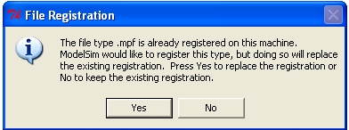

You may click on Yes to change the registration.
- You may be greeted by a dialog that you can dismiss by clicking on the ‘Close’ button.
- Select from the menu File:New:Project. Everything in ModelSim initially should be done in the context of a project. This is its mechanism for keeping track of files and design settings.
- In the New Project dialog, enter the name ‘intro’ in the top text window, change the Project Location to My Documents through use of the Browse button, leave the other settings as they are. See figure following. Click OK.
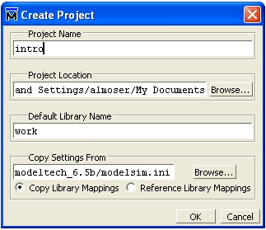

- You will then be greeted by the Add Items to Project dialog. See figure following.
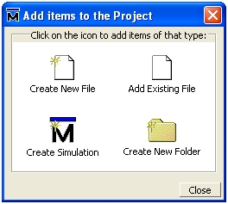

- Click on the Create New File icon. You will then get the Create Project File dialog: 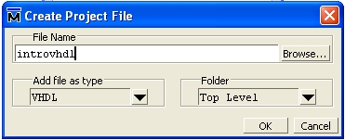

Fill in the File Name textbox with introvhdl as shown above and click OK. Next, click on the Add Existing File icon. Copy the file tintro.vhd from the class web site to My Documents. This is a VHDL file that has been designed to test the intro code to come. In the Add Project File dialog, browse to tintro.vhd and choose it. Then click OK on the Add Project File dialog as well. You should now see two files in the project window, as shown below. You can now close the Add Project Items dialog.

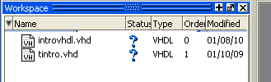

- By the way, the question marks indicate that the code has not been compiled yet, so its validity is unknown.
- VHDL code for this introduction is extremely simple. You can cut and paste it from this document into the text file introvhdl.vhd. Double click on the icon for introvhdl.vhd See below for the code to cut and paste. I have tried to put all the keywords of VHDL into all uppercase so you can spot them, but VHDL does not require them to be uppercase. The first group of instructions tells the hardware compiler to use a certain library of definitions and functions and then which parts of that library. You can probably use the same set of instructions at the beginning of your source code for years without even needing to understand much about the instructions. The second, and only complicated part, is the description of the ‘container’ of this circuit, which is termed an ‘entity’. We have to define input and output names. Let’s say the inputs are A, B, C, and D, from top to bottom. The output will be called E. The input-output description is called an entity and the circuitry inside is called its architecture. See below.

LIBRARY ieee;
USE ieee.std_logic_1164.all;
USE ieee.numeric_std.all;
USE ieee.std_logic_arith.all;
USE ieee.std_logic_unsigned.all;

ENTITY intro is
PORT (
A : IN STD_LOGIC;
B : IN STD_LOGIC;
C : IN STD_LOGIC;
D : IN STD_LOGIC;
E : OUT STD_LOGIC);
END intro;

ARCHITECTURE behavior OF intro IS
BEGIN
E <= (A OR B) AND (C OR D);
END architecture behavior;

We will learn how to use a simulator and a download tool for code like this in a future lab. Save this file.
- We will now do a basic simulation of this circuit.
- Select Compile:Compile All from the menu. The bottom window of ModelSim will have added some lines of text commands describing what it is doing. If you have been careful and with a little luck, no error messages appear.
- If all appears to have gone well, in the workspace window on the left side of the page, click on the Library tab, then click the plus sign to the left of the ‘work’ library symbol. It should show both the entities intro and testintro. ‘testintro’ is in the tintro.vhd file. Right-click on testintro and choose Simulate.
- The workspace window has multiple tabs now. You can choose the Project tab and double-click on tintro.vhd to examine the testbench code. Note that the intro entity is contained as a component of the testintro entity.
- Go back to the sim tab in the workspace window. From the menu select View:Wave. This is where we can watch our simulation on a time axis. Right-click on the testintro entity and choose Add Wave. Now our signals are listed in the Wave window.
- Choose from the menu bar Simulate:Run:Run 100. This runs 100nS of a simulation at a time. There is not much to see in the first 100 nS because the testbench waits for 100nS before doing anything. Choose Simulate:Run:Run 100 repeatedly to see more of the simulation in the Wave window. There is a shortcut tool in the Toolbar that looks like
- You can now verify visually that the entity intro behaves as expected.
- Exit ModelSim with File:Quit.

Lab Report:

You will submit on Canvas a Word document containing your report and text files containing your final, working VHDL and ASM source code. Your report will have the following sections.
- Cover Page with lab title and your name.
- Screenshot of QtSpim with the console window showing the results of the swap.s program
- Screenshot of ModelSim simulating the intro VHDL project with the waveform of the signals

Files to be submitted:

Lab report
VHDL source code for the project
ASM source code for the program

